Changes from the Original AgriCL-Net Plan
Nov 11, 2026 · @DEV

At a Glance
The revised plan removes DETR, adds a leaf-finding step, and splits the pipeline into a severity path and a learning classifier path.
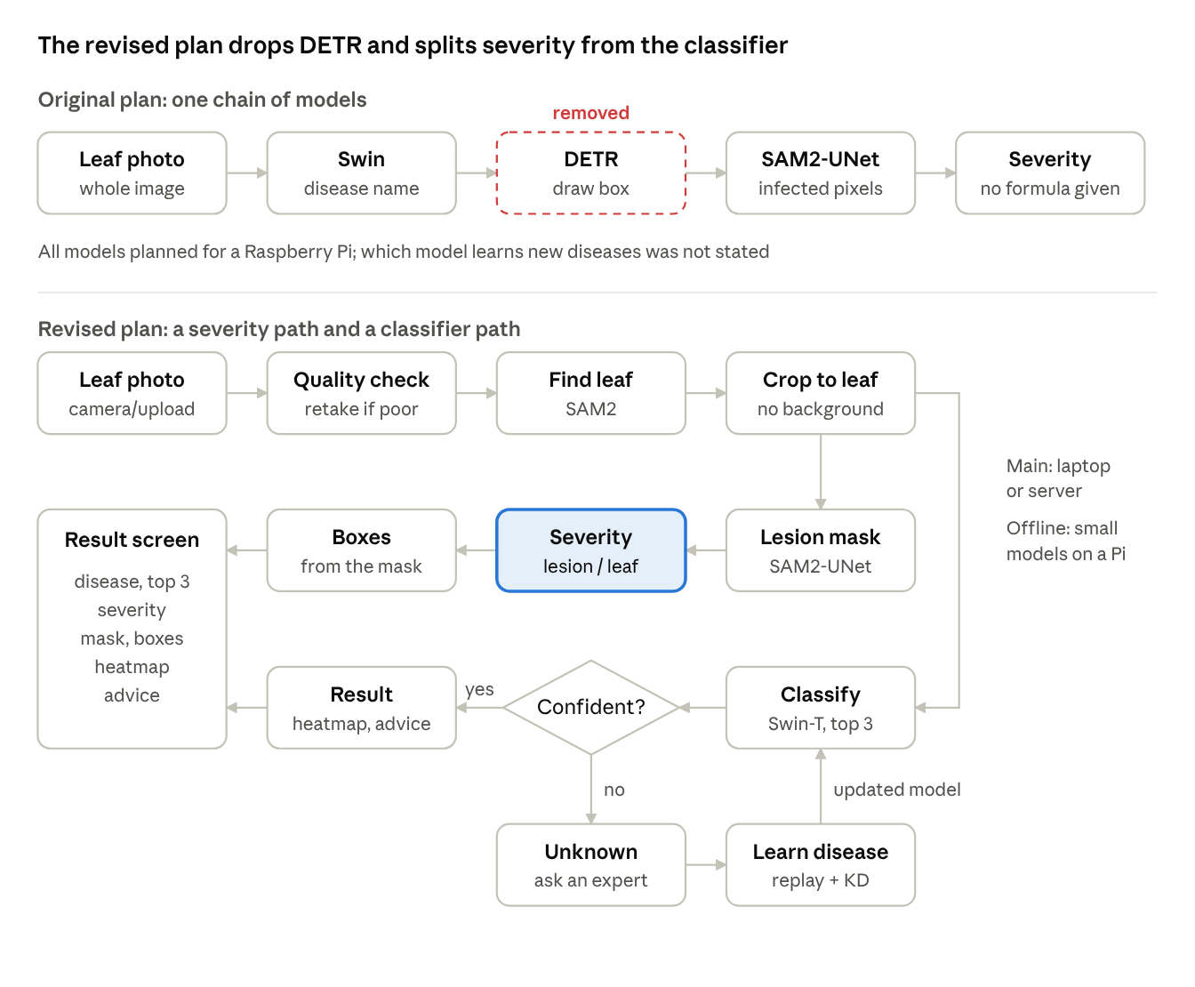
Original vs. revised AgriCL-Net pipeline
In the original chain, every stage depended on the one before it. In the revised plan, severity is calculated without the disease name, so it still works when the classifier answers "Unknown".

Summary of Changes
The revised plan keeps the original goal (diagnosis, severity, continual learning, edge use) but changes how it is built, so that it is accurate, achievable on free GPUs, and different from the base papers.
# | Area | Original plan | Revised plan | Main reason
1 | Detection | DETR draws bounding boxes | Boxes computed from the lesion mask; DETR removed | DETR added cost but no new information
2 | Leaf area | Not addressed | SAM2 segments the leaf | Severity needs the leaf area, which PlantSeg masks do not provide
3 | Segmentation | SAM2-UNet marks infected pixels; labels and training data not defined | SAM2-UNet with one "lesion" class for all diseases | Works for new diseases without retraining
4 | Classifier input | Whole photo | Photo cropped to the leaf | Background clutter is the main cause of errors on field photos
5 | Continual learning | Whole pipeline (unclear) | Classifier only | Only the classifier needs to learn disease names
6 | Unknown diseases | Always gives an answer | Says "Unknown, consult an expert" and saves the image | Avoids confident wrong answers and feeds the learning loop
7 | Output | Disease name only | Top 3 diseases, calibrated confidence, Grad-CAM, advice | More trustworthy and explainable answers
8 | Deployment | Swin, DETR and SAM2 on a Raspberry Pi | Full models on laptop or server; distilled INT8 models as offline fallback | The original models are too heavy for a Pi
9 | Datasets | Not specified; PlantVillage (lab images) listed as a reference | PlantSeg + PlantVillage + PDSNets dataset | Field images, real lesion masks and severity ground truth
10 | Novelty | Combination of two base papers | Severity that works for diseases not yet learned | Gives the project its own claim
11 | Evaluation | Not defined | Metrics and baselines for every stage | Results can be measured and defended
12 | Document errors | Name and requirement mismatches | Corrected and made consistent | Accuracy of the submitted document

1. Model and Pipeline Changes
The revised pipeline replaces DETR with a pretrained leaf finder (SAM2) and gives each trained model one clear job, which makes it simpler to build and more accurate.

DETR removed (change 1)
- Original: DETR was a separate stage that drew a bounding box around the infected area.
- Revised: bounding boxes are computed from the lesion mask with a few lines of OpenCV.
- Why: the lesion mask already shows exactly where the infection is, so a box model adds no new information. Removing DETR saves one model to train, the box annotations it needs, and its inference time. PlantHealthNet itself lists the sequential multi-model pipeline as a cause of high latency.

Leaf segmentation added (change 2)
- Original: severity was calculated "from the pixel count", but the plan did not say how the leaf area would be found.
- Revised: SAM2, used pretrained without training, segments the leaf.
- Why: severity = lesion pixels / leaf pixels, so the leaf area is required. PlantSeg masks mark only diseased pixels, not healthy leaf, so the leaf area must come from somewhere else.

One lesion class for segmentation (change 3)
- Original: SAM2-UNet marked infected pixels, but the labels and training data were not defined.
- Revised: all PlantSeg disease classes are merged into one "lesion" class, so the model only answers "diseased or not" for each pixel.
- Why: a lesion looks like a lesion whatever its name, so this model works on new diseases without retraining. It is also a much easier task: PlantSeg's own authors report only about 46% mIoU when segmenting all 115 diseases separately.

Classifier sees only the leaf (change 4)
- Original: the Swin Transformer classified the whole photo.
- Revised: the photo is cropped to the leaf found by SAM2 before classification.
- Why: field photos contain soil, other plants and shadows. Removing them lets the classifier focus on the symptoms, which is the main way to improve accuracy on field images.

2. Severity and Dataset Changes
Severity is now measured against real ground truth, and the training data now includes field images with expert-checked masks.

Datasets defined (change 9)
- Original: no training dataset was chosen; PlantVillage was only listed as a reference.
- Revised: three public datasets, each with a clear job:
  - PlantSeg v7: field images of 115 diseases on 34 plants with lesion masks, used for lesion segmentation and classification.
  - PlantVillage: lab images, mixed in as extra classification data.
  - PDSNets dataset: 240 field images labelled as background, healthy leaf and disease spot, used to test leaf segmentation and severity.
- Why: PlantVillage alone is lab images on plain backgrounds, and models trained only on lab images lose accuracy on field photos. PDSNets reported F1 drops of 27% to 61% when models trained on one image type were tested on the other. Mixing both types fixes this.

Severity calculation made precise
- Original: "the system calculates a severity percentage" from the pixel count, with no formula, thresholds or way to check it.
- Revised: severity = lesion pixels / leaf pixels × 100, graded Mild (below 20%), Moderate (20% to 50%) or Severe (above 50%), the thresholds used by PlantHealthNet.
- Why: a precise formula can be tested. The PDSNets dataset has healthy-leaf labels, so predicted severity can be compared with the true severity using R² and RMSE.

3. Continual Learning and Unknown-Disease Changes
Continual learning now targets only the classifier, and the system can now admit when it does not know a disease.

Continual learning limited to the classifier (change 5)
- Original: a continual-learning module (replay buffer, herding, knowledge distillation) was described for "the model", without saying which of the three models it updates.
- Revised: only the Swin-T classifier learns new diseases. Each round trains on the new disease images, a replay buffer of about 20 images per old disease chosen by herding, and knowledge distillation from the previous model (cross-entropy plus KL divergence). The output layer is then rebalanced (weight aligning) so new classes do not dominate.
- Why: the lesion model uses one class for every disease, so it does not need to learn new names. Limiting the loop to the classifier makes it simpler to build and gives a clean experiment to report.

Unknown-disease detection added (change 6)
- Original: the system always returned a disease name, even for a disease it had never seen.
- Revised: the classifier's confidence is calibrated (temperature scaling). Below a threshold, the app answers "Unknown, consult an expert" and saves the image for the next learning round. A mismatch between the classifier and the lesion mask (e.g. "healthy" but many lesion pixels) is flagged as uncertain.
- Why: a confident wrong answer leads to wrong treatment. Saying "Unknown" is safer for farmers, and the saved images give the continual-learning loop its new data, so the two features work together.

4. Deployment and Accuracy Changes
The accurate models are now the main system, and small models are an offline fallback, instead of forcing heavy models onto a Raspberry Pi.

Two deployment modes (change 8)
- Original: Swin Transformer, DETR and SAM2-UNet were to be "shrunk (quantized)" and run on a Raspberry Pi or Jetson Nano.
- Revised:
  - Main mode: the full-accuracy models run on a laptop or server.
  - Offline fallback: small student models (MobileNetV3 for classification, LinkNet-ResNet18 or PDSNetx0.5 for lesions) are trained by knowledge distillation from the full models, quantized to INT8 with ONNX Runtime, and run on a Pi or Jetson.
- Why: these three transformer-based models are too heavy for a Pi even after quantization; PlantHealthNet itself names its computational cost as a limitation for edge devices. The split keeps answers accurate when a laptop or connection is available, and still works offline. The small models lose little accuracy: PDSNetx0.5 is only about 0.7% F1 below LinkNet, and PlantKD-CLNet's distilled MobileNetV2 reached 97.0%.

More trustworthy output (change 7)
- Original: the farmer saw one disease name, the infected area and a severity level.
- Revised: the result screen shows the top 3 diseases with calibrated confidence, the lesion mask and boxes, the severity level, a Grad-CAM heatmap of what the classifier looked at, and treatment advice from a lookup table.
- Why: a single guess is often wrong when diseases look alike. PlantHealthNet's classifier was right 85.6% of the time on its first guess but 96.2% within its top 5. The heatmap shows why a decision was made, and the advice table delivers what the original abstract promised ("what to do about it") but no stage produced.

5. New Sections Added
Two sections were added so that the project has its own claim and a way to prove it.

Key Contribution (change 10)
- Original: the design was PlantHealthNet's pipeline (Swin, DETR, SAM2-UNet, severity levels) plus PlantKD-CLNet's continual learning (replay, herding, distillation, quantization). An examiner reading the references would see it as a combination of two existing papers.
- Revised: the claim is that severity keeps working for diseases the classifier has not yet learned, because severity is measured by the lesion model, not the classifier, while the classifier learns new diseases without forgetting.
- Why: our literature search found continual learning for plant disease only for classification or detection, and severity estimation that is trained once and never updated. The claim is worded "to our knowledge", because no search is complete.

Evaluation Plan (change 11)
- Original: no metrics, baselines or experiments were defined.
- Revised: every stage has metrics and a comparison:
  - Classifier: top-1/top-3 accuracy and F1.
  - Confidence: calibration error and unknown-detection AUROC.
  - Lesion and leaf masks: IoU and Dice.
  - Severity: R² and RMSE.
  - Continual learning: average incremental accuracy and forgetting, against plain fine-tuning and joint training.
  - Edge mode: model size, latency and accuracy before and after INT8.
- Why: results make the project defensible. The most important experiment is severity accuracy on diseases held out of training, because it is the direct test of the key contribution.

6. Corrections to the Original Document (change 12)
Several mismatches and errors in the original documents were fixed so the submitted version is consistent.
Issue in the original | Correction
The draft listed "K.Jahnavi", and its roll numbers did not line up with the names | Final list used: U. Jahnavi, A23126510258, with every roll number matched to its name
Storage was 10 GB in the documentation but 20-50 GB in the presentation | One figure: 20 GB free storage, with training on Colab or Kaggle GPUs
Software list included both ONNX Runtime and TensorFlow Lite | ONNX Runtime only, since all models are PyTorch
The Stakeholders introduction had a stray sentence about agronomists merged into it | Rewritten as one introduction plus a stakeholder table
The workflow page was an image with no explanation | Workflow drawn as a diagram and explained step by step
The abstract promised advice on "what to do", but no stage produced it | Treatment advice lookup added to the output
Reference 8 (federated learning and few-shot adaptation) was listed but never used | Removed
The DETR reference (Carion et al.) supported a stage that has now been removed | DETR reference removed; references added for PlantSeg, SAM2, SAM2-UNet, open-world plant disease detection, knowledge distillation, calibration and Grad-CAM

